**Task 1: Describe the Relationship and Create an ERD (Entity-Relationship Diagram)**

The provided files (`results.csv`, `shootouts.csv`, and `goalscorers.csv`) have a common set of columns (`date`, `home_team`, and `away_team`) that can be used to establish relationships between them. These relationships can be represented in an ERD. However, text-based communication doesn't allow me to directly draw an ERD, so I'll describe how these files are related and how they could be represented in an ERD:

* The `results.csv` file contains information about matches, including teams, scores, tournaments, locations, and whether the match was played at a neutral venue.
* The `shootouts.csv` file contains information about penalty-shootouts, including the match date, home team, away team, and the winner of the shootout.
* The `goalscorers.csv` file contains information about goal scorers, including the match date, teams, scorers, and additional details about the goals.

**ERD Representation:**

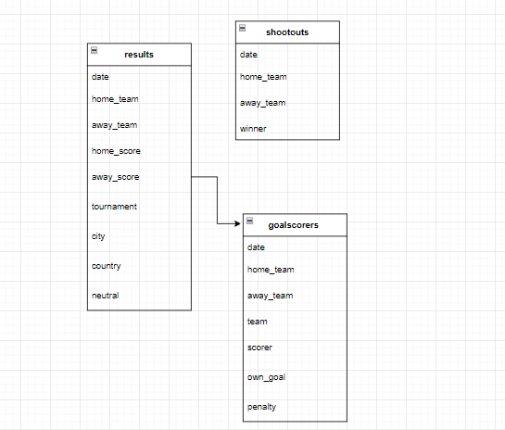

**Advantages of this ERD Format:**

* Clearly illustrates the relationships between different entities (collections).
* Allows you to understand how data from different files is connected.
* Provides a visual representation for easier communication and documentation.

**Disadvantages:**

* The ERD might become complex when dealing with large datasets or multiple interconnected collections.
* The ERD doesn't represent specific query structures or data access patterns.

**Suitability for the Provided Data:**

* + The ERD format is suitable for understanding the high-level relationships between different entities based on shared attributes.
  + It might not be suitable for capturing complex queries, aggregation pipelines, or advanced data manipulations.